Final Autumn: Climate Catastrophe and Its Spiritual Dimensions
By Betty J Dabney, PhD

Introduction

The following scenario and characters are fictional, but similar events could happen where you live:

October 26, 2065 dawned just like any other day for Wang Liu-Wen. He awoke in his small apartment on the fifth floor of a prestigious building in a coastal city by the sea. His wife, Shia-Wei, was still asleep at his side but was beginning to stir.

Liu-Wen considered himself lucky to be in this building. While it didn’t have the panoramic view of those higher in the mountains, it did have the convenience of being right on the harbor. This saved him at least half an hour in his morning and evening commute in his luxury automobile to his job as a supervisor in a software company. He could have taken mass transit, but that would not be fitting for a man of his prestige.

Slowly Liu-Wen got out of bed and reminded Shia-Wei of their dinner party that night. She had ordered special food for it, as well as fresh flowers to decorate their dining room.

Liu-Wen dressed quickly, for there was an important meeting at work with several international vice-presidents who had flown in for the occasion. They could have had a virtual meeting on-line, but these executives liked to fly to Hong Kong for the food and night life.

Always at the cutting edge of technology, Lie-Wen started his car remotely as he drank the last sip of tea and programmed it to drive itself from the parking place in the garage to the front door of the building. The car was waiting for him by the time he arrived downstairs.

Driving along the harbor to his office, Liu-Wen noticed something strange. There was a small leak in the retaining wall that had been built around the harbor to offset the rising sea level. He could see the water trickling down from one spot in the middle of the wall. Many other cities had taken this approach of walling themselves off from the ocean rather than move inland: New York, London, Singapore, and Kuala Lumpur. The engineers assured them it would be less expensive than moving and re-building the cities inland at higher elevations.

Quickly checking his portable data center on his wrist for real-time sea level in Hong Kong, he saw something alarming: over the past week the sea level had begun to rise even faster than its usual one centimeter per year. Something was happening that had not been anticipated. He looked at the data for other locations in the world; whatever was happening here was also going on in other parts of the world. He was gripped with a fear that scientists had been warning: it was as if all the polar ice had reached a tipping point and melted at once, in the space of a few days.

He looked at the real-time satellite image of Greenland and saw no ice, no snow. Moving his view to the Alps, then the Himalayas, he saw a similar picture: all the snow cover and glaciers were gone. All of them.

“It will be alright,” thought Liu-Wen. “We will have time to react. It won’t take long to build another level on the sea wall.”

The meeting went well, but Liu-Wen kept thinking about what he had seen. He tried to persuade his colleagues to turn the loss of ice and rising sea level into a new business opportunity. At the end of the meeting, Shia-Wei called.

“There is no food, Liu-Wen.”

Liu-Wen was incredulous. “What do you mean, no food?”

“The droughts in China and South America caused crop failures and the grocery cannot get the food we ordered for our dinner party. I checked with other stores in the on-line inventory – it’s the same everywhere. What are we going to do?”

Liu-Wen couldn’t answer. Instead, he stared at the wall of his office and realized that the predictions of the past fifty years were coming true. Then, as he drove home past the sea wall it collapsed. The water came and swept him away.

And, unbeknownst to Liu-Wen, at that moment the last polar bear died.

* * *

If Rachel Carson were alive today, fifty-three years after the publication of her seminal book Silent Spring, she might have written this as an introduction to its sequel. Now instead of mass extinction of birds all life on earth is in peril. The mass of humanity on the earth and its never-ending greed for consumption of material goods made from non-renewable resources has exceeded the capacity of the earth to support the life on it.

“Final Autumn” is the new Silent Spring. Each of us has a moral obligation to understand what is happening to the earth and to take personal action to prevent this apocalypse from becoming reality. In this article you will learn about the current and predicted effects of Climate Change around the world and how our reaction can be part of a spiritual practice. Whether they affect you directly or not at the present, it is just a matter of time before they might. We cannot continue with “Business as Usual” or the earth will not be able to support life as we know it within two generations, about fifty years.

What Is Climate Change?

Climate Change, which was formerly called Global Warming, is the unprecedented increase in the earth’s temperature that has been occurring since the Industrial Revolution over the past 100 years or so. While weather refers to acute (short-term) atmospheric events that occur over a period of days to months, climate is measured in decades.

Al Gore’s Climate Reality Project lists ten key indicators of Climate Change (https://www.climaterealityproject.org/blog/10-indicators-that-show-climate-change?utm_source=Facebook&tum_medium=Social&utm_campaign=general – Accessed 19 August 2015):
- Increasing air temperatures over land;
- Increasing air temperatures over oceans;
- Decreasing Arctic sea ice;
- Melting glaciers;
- Rising sea levels;
- Increasing humidity
- Increasing ocean heat content;
- Increasing sea surface temperatures;
- Decreasing snow cover;
- Increasing temperature in the lower atmosphere.

What is causing this unprecedented warming of the earth? As shown in Figure 1, there has been a close association with concentrations of atmospheric carbon dioxide (CO₂) and the surface temperature of the earth for the entire historical record of 400,000 years. Recently both have risen dramatically, and most of this increase can be attributed to burning fossil fuels (coal, oil, gasoline, and natural gas). Indeed, the correlation between CO₂ and global temperature for the entire historical record is remarkable. Other gases such as methane and oxides of nitrogen (the latter also products of fossil fuel combustion) can contribute as well, but the greatest contributor is CO₂.

Carbon dioxide occurs naturally and normally in the atmosphere. Our bodies and all animals produce it with every breath from the metabolism of our food. Plants use it in a reverse pathway called photosynthesis to convert CO₂ into organic carbon-based compounds. Thus plants and animals complement each other in their needs and exist in a beautiful mutually beneficial relationship. But when the concentration of CO₂ becomes too high the equilibrium is thrown off. Indeed, at very high concentrations (above ca. 10% or 100,000 ppm), CO₂ is an asphyxiant and can cause death by displacing oxygen.

In May 2014 the concentration of atmospheric CO₂ reached an all-time high of 400 parts per million (ppm), and it is still climbing steadily. There is some agreement that 350 ppm is the highest level that will not cause irreversible harm. We are already past that point, and the CO₂ is now rising exponentially – that is to say the rate of increase itself is increasing. This concentration has never occurred in the historical record of 400,000 years determined from analyzing CO₂ concentrations in trapped air bubbles of very old Antarctic ice. Indeed, climatologists have gone back to the drawing board to develop new models because the rate of change is ten times faster than previously thought. Ten times faster.

How do these gases make the earth heat up? They act as blankets in the earth’s atmosphere and trap the heat radiated by the earth. Figure 2 shows this in a simplified way.

At the present time 99 percent of climate scientists agree that the rise in global temperature is real and is anthropogenic (man-made). They believe if the temperature rises more than 2º C from where it was in 1970 and/or if the CO₂ is higher than 350 ppm, the earth is in danger of reaching a “tipping point” where the changes may be irreversible. The historic upcoming 21st Session of the Conference of the Parties to the United Nations Framework Convention on Climate Change (COP21/CMP11 “Paris 2015” November 30th to December 11th has set a goal for the 193 member countries. It is to reduce global CO₂ emissions by at least 60% below 2010 levels by 2050. However, some scientists (including this one) feel this goal is too little, too late.

In spite of the overwhelming evidence for Climate Change, there is still a great deal of resistance to change on the part of both governments and individuals. They just don’t seem to grasp that life as we know it hangs in the balance. We need a new terminology to describe what is occurring with Climate Change. Scientists have recently begun to use the term Climate Crisis, but that may not sufficiently convey the urgency of the situation. Therefore I propose the name Climate Catastrophe to describe what is happening around the earth now as a result of anthropogenic activity. Viewing the situation as a catastrophe in the present rather than a vague goal many years off may be enough to motivate many people to change their behavior and make a difference.

What Are the Effects of Climate Catastrophe and Why Should We Be Worried?

Within the space of two generations (ca. 50 years), Climate Catastrophe will affect every aspect of life as we know it. In some cases it already has. For the sake of simplicity, we will discuss these effects on the classical elements of Earth, Air, Fire and Water.

- Earth
There will be dramatic changes in the food supply. Partly because the practice of monoculture has led to depletion of nutrients in the soil, partly because the inexorable creep of warmth toward the more temperate latitudes will require traditional crops either to adapt to heat or grow in higher latitudes/altitudes. Not all crops will be able to adapt. We will see total crop failures and severe famine with increasing frequency and perhaps extinctions of some crops altogether. Severe drought (see discussion under “Water”) will become commonplace.

As food shortages develop in the local and global markets, there will be increasing competition for the limited supply. A joint US-British Task Force on Extreme Weather and Global Food System Resilience recently concluded that global food shortages will be three times more likely because of Climate Change. Events that were previously occurring once a century are now predicted to occur every 30 years. Food riots and armed conflicts over food will occur. As in every situation of limited resources, prices will skyrocket and the poor will be left behind, perhaps to the point of not being able to buy, find, or grow enough food to survive. As food becomes more and more scarce, more and more people will become marginalized and more famines will occur.

Humanity will need to change the way it eats and become vegetarian or even vegan, because of the great quantities of water required to raise meat in comparison to vegetables, and water is in critical shortage (See Section on “Water” below). Figure 3 shows some examples of the cost in water of different kinds of foods. It is evident that all foods from animals require more water kilogram-for-kilogram than plant-based foods. This is simply because animals grown for food traditionally eat plant-based diets but must further convert the plants into meat and fat. It would be more efficient if people eliminated the animals and ate plants directly.

Perhaps a more pertinent comparison would be the amount of water required to produce different foods normalized to total caloric value, protein and fat. In Table 1 we can see that animal-based foods still require more water than most plant-based diets, with beef being the highest consumer of all. Exceptions are fruits and nuts, which are less efficient than beef for using water to make protein but are still more efficient for overall calories. Vegetables in general require only one-fourth to one-seventh as much water per gram of protein, the most critical component because protein deficiency is the most common type of malnutrition worldwide. Thus a worldwide food catastrophe will be part of Climate Catastrophe. Indeed, some parts of the world are already affected.

In its never-ending demand for more material goods and an unhealthy Western diet that accompanies economic development, people are destroying habitats at an unprecedented rate. Rain forests are cleared to make room for raising beef cattle and palm oil plantations, and are no longer available to sequester CO_{2.} Palm oil plantations threaten the survival of endangered orangutans. Oil-producing plants are the most efficient at trapping CO₂ because oil has twice as many calories per gram as carbohydrate or protein. Oil-producing plants would be more valuable to the planet if they were allowed to grow unmolested to suck up CO_{2.}

Besides extinction of some crops, there will be mass extinctions of wildlife in those species that cannot adapt to warming or find new habitats. This so-called “Sixth Great Extinction” has been described by Elizabeth Kolbert in her book The Sixth Extinction, winner of the 2015 Pulitzer Prize for General Non-Fiction in the US. While species extinctions and emergence of new species are constantly occurring, the earth is entering an era where the rate of extinctions may be 100 – 1,000 times higher than usual. Scientists are concerned about the Sixth Extinction because it is largely anthropogenic.

While the actual number of species is not known, one study estimated that 75 percent of vertebrates could be extinct within several lifetimes, and several thousand are becoming extinct every day. Some scientists have named this the Anthropocene geological era because the effects of humankind on species and topology are so large that they will alter the paleontological and geological records. Climate Catastrophe with its droughts, heat waves and storms makes species extinction worse, and Climate Catastrophe will occur faster with destruction of vegetation no longer available to sequester CO₂.

We will also see different global distributions of diseases as the earth warms. Tropical diseases will creep toward formerly temperate climates and cover larger areas. New heat-resistant strains of infectious agents will appear as part of their adaptation and evolution. This is already evident for some diseases. For example, highly infectious bacterium Vibrio vulnificus from shellfish has been reported in more northerly areas for the first time. Harmful algae blooms (red tides) from massive infestations of algae will also become more frequent in higher latitudes in coastal areas.

Once begun, Climate Catastrophe and ecological destruction feed on each other like a dragon eating its tail. Because everything is connected and inter-dependent, when we deliberately destroy life of any kind we will ultimately destroy ourselves.

- Air
The primary effect of the increasing CO₂ levels is increasing global temperature in different media as discussed above. Scientists most commonly use surface air temperature and surface ocean temperature, however. The surface ocean temperature is discussed under “Water”.

With respect to surface air temperature, 2015 is on track to be the hottest year on record. Thirteen of the past fifteen years were each the hottest on record at the time according to Climate Central, and the odds of that happening randomly without the influence of Climate Change were 1 in 27 million (www.climatecentral.org, accessed 20 August 2015) .

Disequilibrium at a global scale produced by increasing temperature also causes disequilibrium with respect to air currents. In addition, there is more thermal energy in the oceans and air. More water can evaporate, and the warmer air can hold more water. Hence one can expect storms, hurricanes and typhoons, tornadoes, and acute weather events such as rain, hail and snow to be more intense and more frequent. Already we are seeing an increase in severe tornadoes in the US, and the winter of 2014-2015 saw record-breaking snowfall in the Northeastern US. As of August 2015 two major typhoons have threatened Taiwan this year, and recently for the first time there were three typhoons present in the Pacific Ocean simultaneously.

Thus we can say with some confidence that there will be increasing loss of life and property from major weather events. Many of the major cities are located in coastal areas and would be especially vulnerable to hurricanes and typhoons (See section on Water below).

In addition to these acute weather events, Global Warming can cause higher levels of ozone pollution. The formation of ozone from nitrogen oxides and particulates is temperature-dependent; hence we can expect more episodes of unhealthy levels of smog as the average air temperature rises. In some areas of India and China, the air pollution is already life-threatening. Approximately 4,000 people die every day in China from its air pollution according to one recent estimate by Robert Rohde at the University of California Berkeley. In countries that have air pollution standards for different pollutants, ozone is the most frequently exceeded. Ozone is a severe respiratory irritant and can make heart disease, asthma and other chronic respiratory diseases worse. Whether or not it can cause these conditions is an open question. Ozone can occur in pockets that travel large distances. Some of the ozone pollution has traveled across the Pacific Ocean from China to the US.

- Fire
High temperatures combined with drought and wind greatly increase the risk of fire. Climate Catastrophe is bringing more fires of larger size and intensity. “Mega-fires”, such as the ones in Greece in the summer of 2007, are too large to be controlled by current fire-fighting resources.

As with the acute weather events described above, one can predict greater loss of life and property from fire as a result of Climate Catastrophe. Normally fire can have a cleansing effect, but vegetation already weakened by prior environmental insults would be less viable and would have more difficulty recovering from fire. Hence we predict the damage from fires will be more extensive and longer-lasting with Climate Catastrophe. Mega-fires may be so extensive that they reduce the availability of wood for lumber, paper and other wood products.

- Water
The amount of water on earth is constant. By far the vast majority of earth’s water is sea water. Only 3% is fresh water, but most of this (68%) has been tied up in polar ice. Another 30% of the fresh water is in underground aquifers. The remainder, only about 0.3% of the fresh water (or 0.009% of the total water), is available as surface water for consumption. Figure 4 shows these relationships.

All the water on earth is inter-connected through the Hydrologic Cycle shown in a simplified diagram in Figure 5. Precipitation in the form of rain or snow falls to the surface and will ultimately run off into lakes, streams and rivers through their respective watersheds. As the earth warms snow and ice melt, producing further runoff. Surface water eventually flows to estuaries and oceans to merge with sea water. The salinity of oceans has been constant because the hydrologic cycle has been in equilibrium. However, warming temperatures are changing this equilibrium to favor melting of polar ice, runoff of glaciers, and dilution of sea water.

Climate catastrophe is already producing many effects on both fresh and salt water at a global scale. Changes in weather and climate patterns are occurring with increasing ocean temperatures. While some areas are experiencing more frequent storms, others suffer from severe drought. The El Niño/Southern Oscillation (ENSO) of surface temperatures in the equatorial Pacific Ocean will become more intense. Indeed, the El Niño occurring now in 2015 may be the most intense on record. El Niño can produce excess rain in some areas of the world and deficiencies of rain in others. Figure 6 shows the predicted pattern of El Niño for September – November 2015, visible as the intense red equatorial band in the Pacific Ocean. Some parts of El Niño are predicted to warm by as much as 3º C this year.

With such an active El Niño, some areas will experience a major excess of rain. California, which was in danger of running out of water earlier in 2015, is predicted to have floods and landslides this autumn and winter. El Niño will exacerbate the extremes of acute weather events from Climate Catastrophe, and Climate Catastrophe will exacerbate El Niño. El Niño oscillates with La Niña, where the Pacific Equatorial region is cooler than the surrounding ocean. With Climate Catastrophe we can expect to see more frequent and stronger El Niños and less frequent and/or milder La Niñas.

One of the main effects of Climate Catastrophe is the rise in sea level. This is due to two causes: melting of polar ice and expansion of the volume of the sea water with warming.

The sea level is rising ten times faster than previously thought. According to NOAA and shown in Figure 7, it has risen on average two inches since 1993. Dr. James Hansen, formerly the chief scientist at NASA, believes sea level may rise as much as several meters in the next 50 years because of melting Arctic ice (Hansen et al, 2015). This will be a crisis for the major coastal cities, who must decide how to deal with it.

According to the United Nations Oceans Atlas, approximately 44 percent of the world’s population lives within 150 kilometers of the sea coast (www.oceanatlas.org) and 40 percent lives within 100 kilometers (http://sedac.ciesin.columbia.edu/es/papers/Coastal_Zone_Pop_Method.pdf)
Readers of this Journal will be especially interested to know that most of Singapore is at an elevation of 15 meters or less (49 feet). In Kuala Lumpur the average is 21.95 m (72.0 ft). While Taiwan is very mountainous, 90 percent of the population lives at 15 meters or lower in the gently sloping western plain.
It is not unrealistic that sea level may impinge on these locations in the next two generations. Much of the populated areas of Singapore, Kuala Lumpur, and Taiwan will be under water.

Interestingly, the sea level is not rising at the same rate uniformly all over the earth. Figure 8 shows the deviation in sea level as of 2013. The highest levels were at Taiwan, Singapore, Malaysia and the Philippines. This deviation may itself vary with time, and whether or not these locations will remain the most elevated is to be determined. It is due to complex factors including interaction of ocean currents with land masses as well as local variations in ocean temperatures. The rapid rise in sea level could be devastating for those locations with the largest deviation and where the population is concentrated near the coast.

Another important effect on water from Climate Catastrophe is the acidification of the oceans. Carbon dioxide can react with water to form carbonic acid. Higher concentrations of atmospheric CO₂ are causing higher concentrations of carbonic acid to form in the oceans. Although it is a weak acid, it is strong enough to dissolve the calciferous exoskeletons of many marine organisms including coral. Thus we are witnessing the death of the Great Barrier Reef, one of the natural wonders of the earth.

Equally important is the effect on some benthics. Benthics are a family of small microscopic animals that are at the bottom of the marine food chain. Destruction of benthics would affect all marine animal life, from the smallest fish to the great whales. This could create a critical shortage of seafood, which comprises an important part of the diet of people living in coastal areas.

The effects of Climate Catastrophe on water are not limited to the oceans. Rivers are drying up all over the world, a result of less glacial and rain runoff in their watersheds combined with high rates of withdrawal for various uses. Some areas are already being affected in their ability to irrigate crops with river water, notably rice farming. Rice is a dietary staple for billions of people in the world whose lack would have far-reaching implications. According to the National Geographic Society, rivers which are already suffering major impacts are the Colorado in the US, Indus in Pakistan, Amu Darya in Central Asia, Syr Darya in Kyrgyzstan and Uzbekistan, Rio Grande in US and Mexico, the Yellow River in China, the Teesta in Sikkim, and the Murray in Australia. Many of these rivers are a lifeline in their countries.

Summary of Climate Catastrophe

Global Warming / Climate Change / Climate Crisis / Climate Catastrophe is real, is largely due to humans’ burning of fossil fuels, and is occurring at a more rapid pace than scientists previously thought. It is affecting many if not all aspects of the lives of lower and higher animals and plants, including humans. We can expect to see unprecedented record heat waves, storms, encroachment on coastal areas by a rapidly rising sea level, rivers drying up, mass extinctions of species, spread of infectious diseases, and widespread food shortages. These effects will cause increased loss of property and life. Life as we know it will not be the same in as few as two generations. It is already changing now.

Different governments are taking different approaches to dealing with Climate Catastrophe. Originally some were in favor of mitigation, i.e. making our infrastructure less polluting. Some feel it is already too late for that because the earth is such a large and complex system that it would not react immediately to changes. Even if we could stop emissions of excess CO₂ today, it would take the earth many years to normalize.

Now it is more common to see plans for adaptation rather than mitigation. This is a more pessimistic approach which assumes that humanity will not be able to stop Climate Catastrophe. Some large coastal cities are planning to erect giant sea walls to keep the rising ocean at bay. Others may need to move inland to higher elevations. Still others, such as the Maldives island nation, may be lost forever and will have to relocate to a higher area.

There is talk of geo-engineering. Some people believe that engineering solutions on a regional or global scale such as intentional introduction of smoke in the stratosphere to block some of the heat (and light) from the sun may be the answer. Unfortunately such large-scale engineering projects cannot be fully tested in the laboratory before they are built, and their success may not be assured. The cost would also be very great. Geo-engineering also provides little or no incentive for people to change their behaviors.

Governments are typically reactionary. They wait until something has become a crisis before acting. Governments also tend to perpetuate the status quo, especially when it is to the benefit of the current military-industrial complex. We can expect governments to proceed with business as usual until there is no other choice. And by then it will be much too late.

This liturgy of the current and expected effects of Climate Catastrophe has been rather impersonal. But the most important point, one which overshadows all the others, is if humanity destroys its own and only habitat this would be the greatest moral outrage in history. We cannot destroy other life without destroying ourselves and vice versa because all life is interrelated. We need the earth, but the earth does not need us. One could make a strong case that the planet would be better off without Homo sapiens. Humanity is acting as if the sapiens has disappeared from Homo.

The scenarios described in this article are not just speculation. Some of them are already happening. If we can’t depend on governments to react in time, then what is left? The answer is obvious – major changes in personal lifestyles that we as individuals have the power to make. There is strength in numbers. We as individuals have the power to change the world if we work together. The remainder of this article will discuss how we can change our lives to heal the earth and save ourselves.

What Does Climate Catastrophe Mean for Us? What Can We Do?

It is difficult to be motivated to change our practices because of Climate Catastrophe if it has not directly affected us yet. Most of us living in urban areas don’t see its effects because we are not directly in touch with nature. But some rural areas, especially the Arctic and sub-Equatorial Africa, have been so changed that the effects are already obvious and devastating. Entire towns in the Arctic are debating whether or not to relocate because the warming has melted the permafrost where their houses are built. Rotting carcasses of livestock dot the lifeless and cracked landscape in Africa where water has run out. For the people living in these places, Climate Catastrophe is ever so real.

But for the rest of us, we need to take actions now that will benefit the whole of humanity in the future. And the sooner, the better. Most importantly, each of us can gladly adopt changes in our own lives as part of our spiritual practice. Helping to mitigate or even reverse Climate Change can bring each of us in closer communion with ourselves, the earth and ultimately the Cosmos.

Most recommendations you will see in other reviews will be the same. These include the “Three R’s”: Reduce, Reuse and Recycle. Popularized by the US Environmental Protection Agency, these are directed toward reducing pollution from material goods. Buy less, use things longer and then dispose of them into recycling waste streams. Certainly these are good practices, but they are only the beginning and are not comprehensive by any means.

Perhaps the greatest impact we can have in our practice is by changing the way we eat. Keeping in mind how much water is required to produce meat vs. fruits and vegetables, we can have a major impact on water sustainability by consuming less or even no meat. According to National Geographic, a vegan saves approximately 600 gallons of water a day compared with a meat-eating person (http://environment.nationalgeographic.com/environment/freshwater/water-conservation-tips/).

We can be more mindful of how we use energy and work to conserve it. Take public transportation where it is available. More demand will produce better public transport and transportation-oriented development, where housing, offices and retail are built with access to public transportation in mind. This is already the case in many highly urbanized areas where people do not own automobiles.

If you are a city planner, you can create complete streets in which retail, housing, offices, trees and attractive public gathering places increase the appeal of urban living for motorists, bicyclists and pedestrians alike. Cities are more energy-efficient than suburbs but often are less desirable as places to live because of pollution and crowding. These undesirable factors can be overcome to some extent by good design. As of 2007 more than half the world’s population lived in urban areas, and it is becoming more urbanized every day.

We can all help by planting trees if we have space to grow them. Trees and other vegetation remove air pollutants, release oxygen, and sequester CO₂. They are one of the most valuable resources for reversing Climate Catastrophe. The rainforests are disappearing such an alarming rate that they will have disappeared completely by 2060 (www.rainforest.org). Rainforests are also a rich source of biodiversity. Biodiversity is important because it provides resilience against sudden or gradual environmental changes. And preserving biodiversity is important for ethical reasons because all living creatures, sentient or not, are important for nature’s balance.

We can still have trees even in a highly urban environment. In fact, the more urban the location, the more important it is to have trees and vegetation. Even high-rise buildings can have trees. One remarkable example of a creative way to provide access to trees and vegetation is the Bosco Verticale (Vertical Woods) in Milan, Italy. This award-winning design by Stefano Boeri and associates is different from many radical ideas in that it has actually been built. Figure 9 shows how it looks today. The façades of the twin towers incorporate 730 trees, 5,000 shrubs, and 11,000 perennials and groundcover of approximately fifty species, equivalent to a hectare of woodland. One example of its brilliant design is the use of deciduous trees which shade the interiors in the hottest months of the year and then provide access to sunlight and passive heating during the winter.

Bosco Verticale is just one example of how nature can be brought to urban dwellers to replace what has been lost. To carry the idea even farther, some people are using edible landscaping. We can’t all live in a luxury condominium like Bosco Verticale, but many of us have some space which can be used for growing plants, especially food. Vertical gardens require a minimum of space and can be surprisingly productive. They are also good projects for children and families to do together.

Growing some of our own food is a good way to keep us in touch with where our food comes from. It is also important to grow the food in a healthy way, in balance with nature. This is what organic farming does. Among other things, organic farming uses only natural materials such as compost and animal waste for fertilizer. It also encourages crop rotation to prevent depletion of nutrients in the soil. And it avoids the use of pesticides. Pesticides are weakening many species important for our plant including honeybees. Honeybees are suffering from Colony Collapse Disorder worldwide. Bees are necessary for many agricultural crops. Without honeybees, the agriculture industry itself would collapse.

If you want to grow some of your own food, we encourage you to adopt organic farming practices. The yields will be just as great, and the food will be better for you and the planet. The United Nations concluded in a recent report that small-scale organic farming is the only way to feed the world (http://www.technologywater.com/post/69995394390/un-report-says-small-scale-organic-farming-only).

If you are a farmer, you may be able to adopt micro-irrigation (drip irrigation) to use much less water. Figure 10 shows one on-line micro-irrigation design where water is delivered precisely to the plants that need it, thus saving up to 70 percent of the water needed to grow fruits and closely-spaced crops (http://www.kotharipipes.co.in/). If you are an agricultural planner, please encourage farmers to use micro-irrigation. It can make a big difference in water consumption. Typically agriculture is the largest consumer of water worldwide; hence any improvements in water consumption for agricultural purposes on a global scale would have a large impact.

Agriculture does not have to be rural. Indeed, the more we can work together to bring agriculture to towns and cities, the more people will benefit from locally grown food. The town of Todmorden in West Yorkshire, UK uses edible landscaping in the village (http://www.incredible-edible-todmorden.co.uk/). All food is freely available to anyone who wants it. Figure 11 shows sweet corn and leafy greens growing on the sidewalk outside the police station! Now similar Incredible Edible Towns are cropping up all over the world, including Hong Kong (https://vimeo.com/36838823)

These practices are part of adopting a sustainable lifestyle. But how can personal sustainability be compatible with economic sustainability? Clearly the world cannot continue to measure economic health by consumption of goods manufactured from non-renewable resources.

One idea is to adopt universal standards for manufactured goods, much like electrical standards. Such standards would allow electronic equipment, automobiles, major appliances and other goods to be made in modules. When someone wants to upgrade their cellular phone, they could slide out the old module and slide in a new one. Such a modular approach would also help to reduce electronic waste, the fastest-growing waste stream worldwide. If you are a manufacturing engineer, perhaps you can persuade your company to adopt modular manufacturing.

It is easy to be overwhelmed by all this bad news of Climate Catastrophe. It is simple to say, “I’m just one person; how can I make a difference?” Just remember, the earth is a collection of 7.3 billion people who are all “just one person”. If we could find a way to get all 7.3 billion people to work together to save the earth from Climate Catastrophe, how wonderful that would be. Governments can develop international treaties and policies, but those will not be enough. It will take large-scale individual action to make a real sustainable difference.

Such action will undoubtedly involve social media, and specifically cell-phone applications. Even in developing countries the vast majority of people have cell phones. We don’t need a new technology to save us; it is already here. Cell phone applications and social media can bring people together who are working on common problems to develop solutions.

To start the ball rolling, I have created a Facebook site called Healing the Earth, Saving Ourselves (https://www.facebook.com/HealingEarthSavingOurselves?fref=ts). It is based on the idea that the earth is dying before our very eyes, but if humanity could set aside its religious, political and other differences and work together to reverse Climate Catastrophe, it would save itself in doing so. I encourage you to join this site; it is a good source of information on innovative ideas for sustainable living.

This is what it all boils down to. We all drink the same water. We all breathe the same air. We all eat food grown on the same earth. These simple yet profound truths transcend any individual differences we might have. So let us use these truths to be the basis of how we can work together. And in so doing, humanity will be transformed into HumanKind. It will discover through practice that kindness, respect and compassion are the key to saving ourselves.

As you think about how you can incorporate these ideas into your own personal spiritual practice, here are some suggestions to help you on your way:
- Always live mindfully. Being in the present moment will keep you connected to the rest of the planet and your inner being. Be aware of how you as an individual depend on so many other things and people for your existence, and be grateful for this every day.
- Tread gently on the earth, literally and metaphorically, being respectful of all life on it both sentient and non-sentient. Who are we to know that any life form may be non-sentient? It is best to treat all life with compassion and respect as if it were sentient. Live intentionally in a way to minimize or even eliminate trash and garbage. Make compost from your waste if you have the space. Encourage your government to have curbside recycling of paper, metal, plastic, glass and compostables.
- Practice lovingkindness in your meditations and in your life. Reflect on your love for all life on earth and for all other beings on earth. Bless those in your immediate existence who make your life possible, from the food you eat to the people in your family and the house you live in. Then bless those who made your family, your food and your house possible. Feel your blessing and your love for all things spread to the ends of the earth.
- Visualize a world where all humanKind works together through mutual compassion and respect to help each other and to heal the world, a world which itself has the fundamental right not to be violated by the people who depend on it for their very existence.

Conclusions

In conclusion, this review has shown some of the more salient effects of Climate Catastrophe. All these effects – Global Warming, melting of glacial ice, rising sea level, more frequent and intense storms, droughts, food shortages, mega-fires, and others – will change life as we know it. And there are undoubtedly other effects not so obvious happening now and in the future. The known effects are occurring much more rapidly than previously thought. What’s more, it is not clear at this point if all species critical to our own survival will survive. If that occurs, the very future of humanity is at stake.

Because the earth reacts slowly to changes in its energy input, it is absolutely critical that these changes occur as soon as possible. The major countries of the world now realize this and have submitted climate action plans to the UN International Climate Change Committee in preparation for negotiating a global treaty in Paris this December.

The broad policies outlined in these countries’ plans cannot be implemented without programs and people. Governments will translate the policies into programs such as quotas on burning fossil fuels that may enforce involuntary compliance. Beyond this, there is much that we as individuals can do voluntarily.

So let us begin now.

References for Further Reading

Conference of the Parties to the United Nations Framework Convention on Climate Change, 21st Session (COP21/CMP11) “Paris 2015” November 30th to December 11th. http://www.cop21.gouv.fr/en Accessed 18 August 2015.

Fifty Ways to Help: http://www.50waystohelp.com/ Accessed 18 August 2015.

Pope Francis: Encyclical Letter Laudato si' of the Holy Father Francis on the Care of Our Common Home. Vatican City: 24 May 2015. http://w2.vatican.va/content/francesco/en/encyclicals/documents/papafrancesco_20150524_enciclicalaudatosi.html. Accessed 25 June 2015.

Hansen, J., Sato, M., Hearty, P., Ruedy, R., Kelley, M., Masson-Delmotte, V., Russell, G., Tselioudis, G., Cao, J., Rignot, E., Velicogna, I., Kandiano, E., von Schuckmann, K., Kharecha, P., Legrande, A. N., Bauer, M., and Lo, K.-W. 2015. Ice melt, sea level rise and superstorms: evidence from paleoclimate data, climate modeling, and modern observations that 2 °C Global Warming is highly dangerous, Atmos. Chem. Phys. Discuss., 15, 20059-20179, doi:10.5194/acpd-15-20059-2015.

Intergovernmental Panel on Climate Change (IPCC): Fifth Assessment Report. Climate Change 2014 Synthesis Report:
Climate Change 2013 The Physical Science Basis:
Climate Change 2014 Impacts, Adaptation and Vulnerability
Climate Change 2014 Mitigation of Climate Change

Klein, Naomi: This Changes Everything: Capitalism vs. The Climate. New York: Simon & Schuster, 2014.

Kolbert, Elizabeth: The Sixth Extinction: An Unnatural History. New York: Macmillan Picador, 2015.

Mekonnen, M.M. and Hoekstra, A.Y. 2010. The green, blue and grey water footprint of farm animals and animal products, Value of Water Research Report Series No. 48, UNESCO-IHE, Delft, the Netherlands, p 28.
Biography

Betty J Dabney, PhD has worked in industry, government and consulting. She has been on the faculties of Texas A&M University Health Sciences Center School of Rural Public Health and the University of Maryland School of Public Health, where she was founding Acting Chair of the Maryland Institute of Applied Environmental Health. Since retirement she has taught health planning at The University of Texas at San Antonio and has also been involved in sustainability issues involving water. She currently lives in San Antonio, Texas with two very spoiled dogs and one cat.

Figures and Table
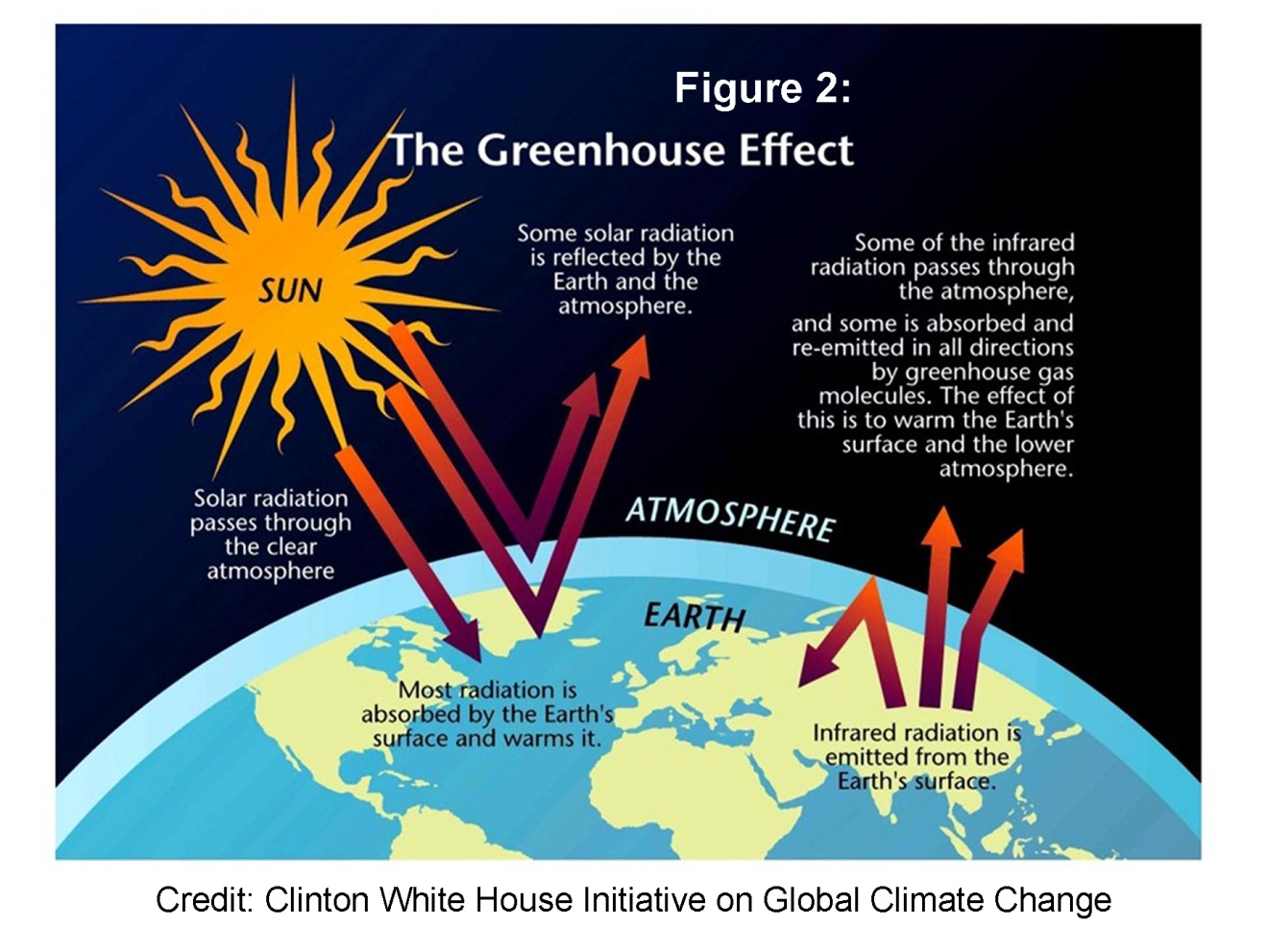
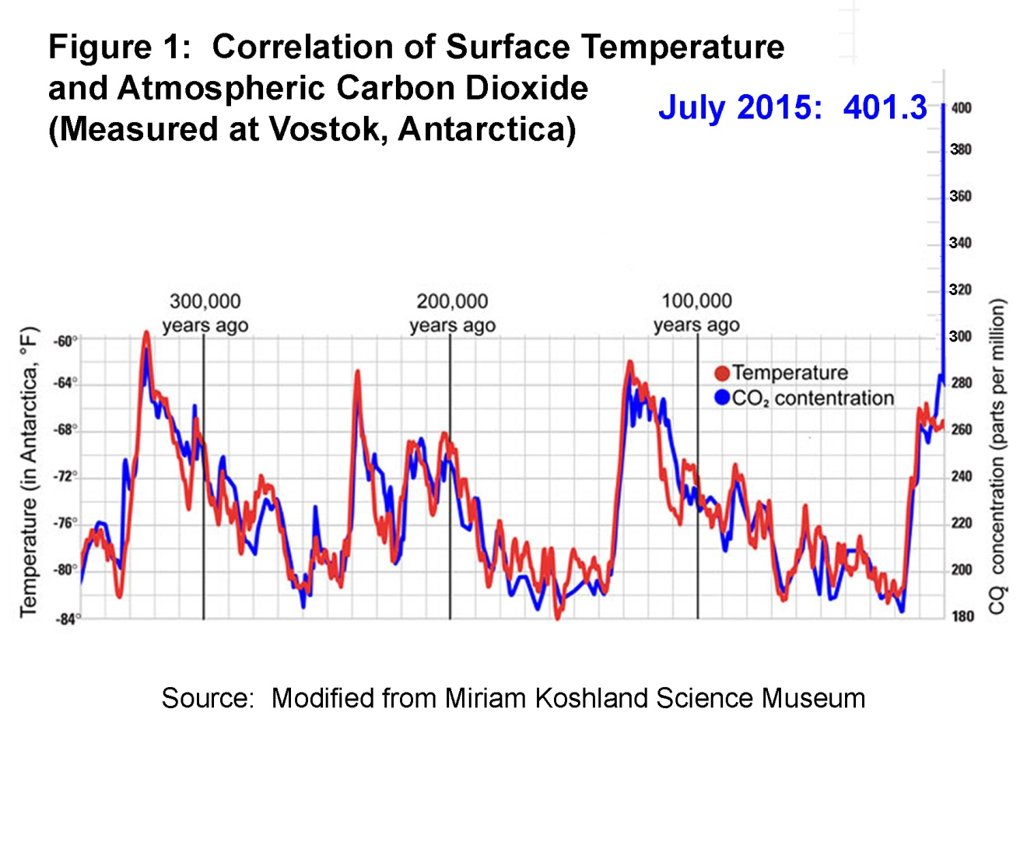
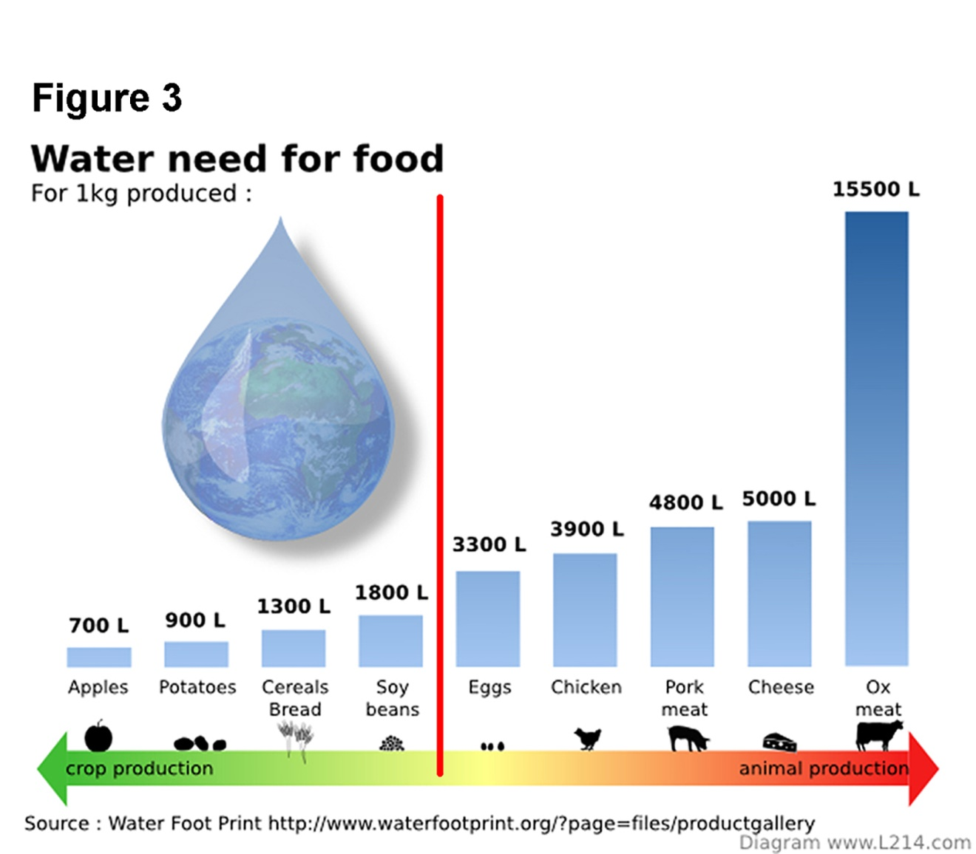
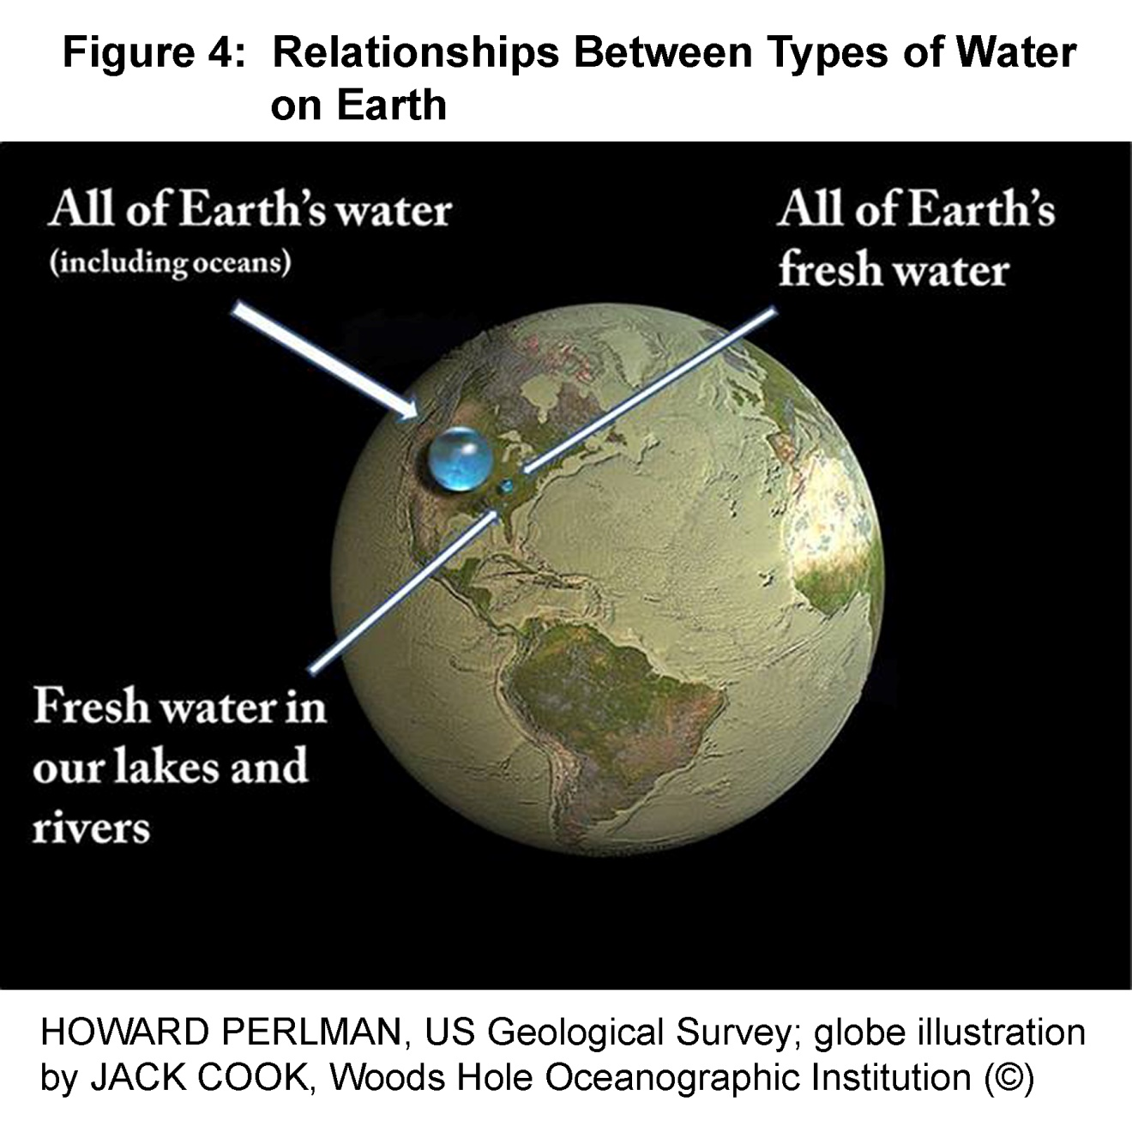
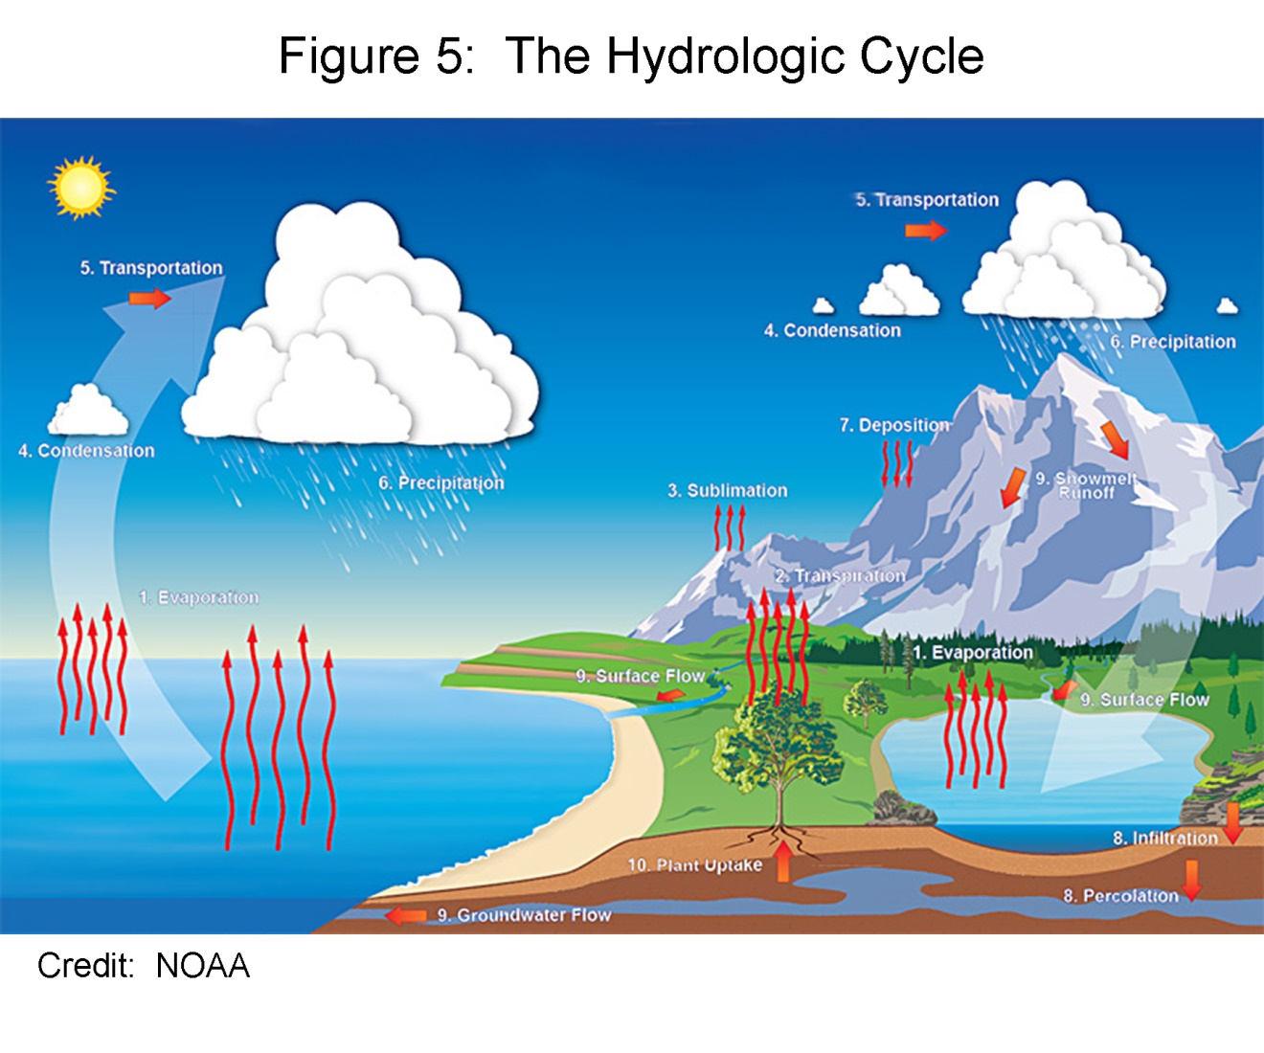
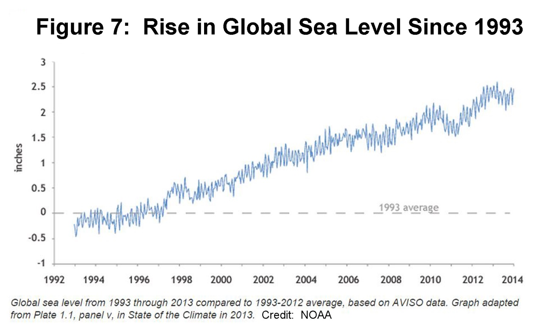
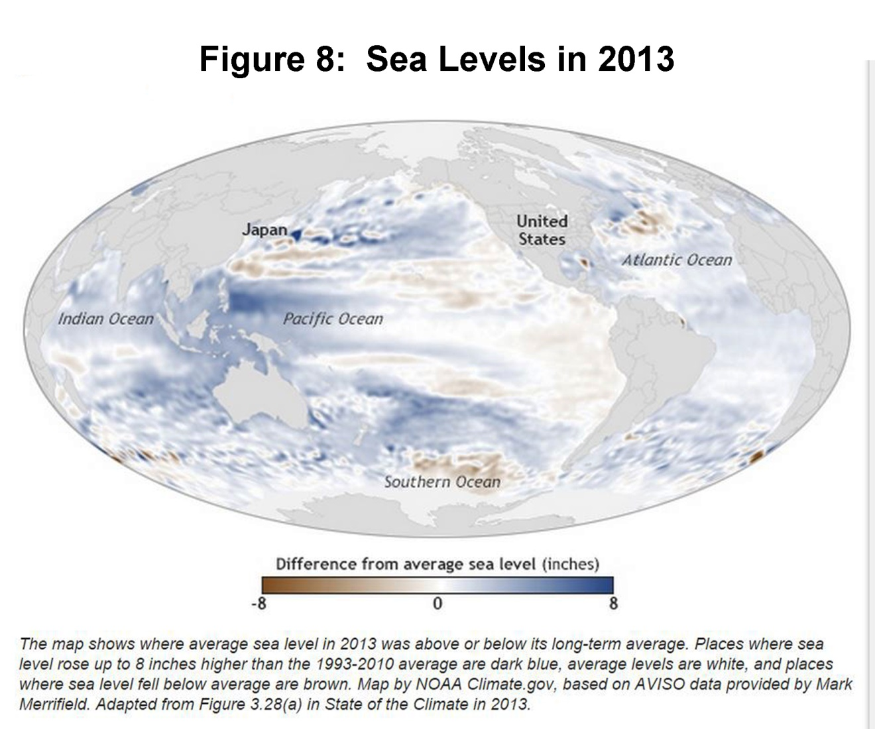
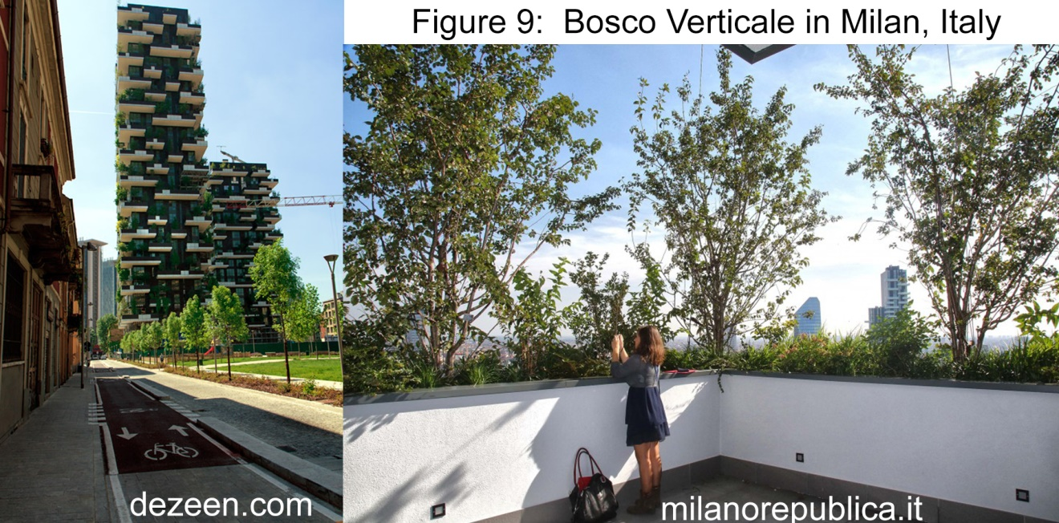
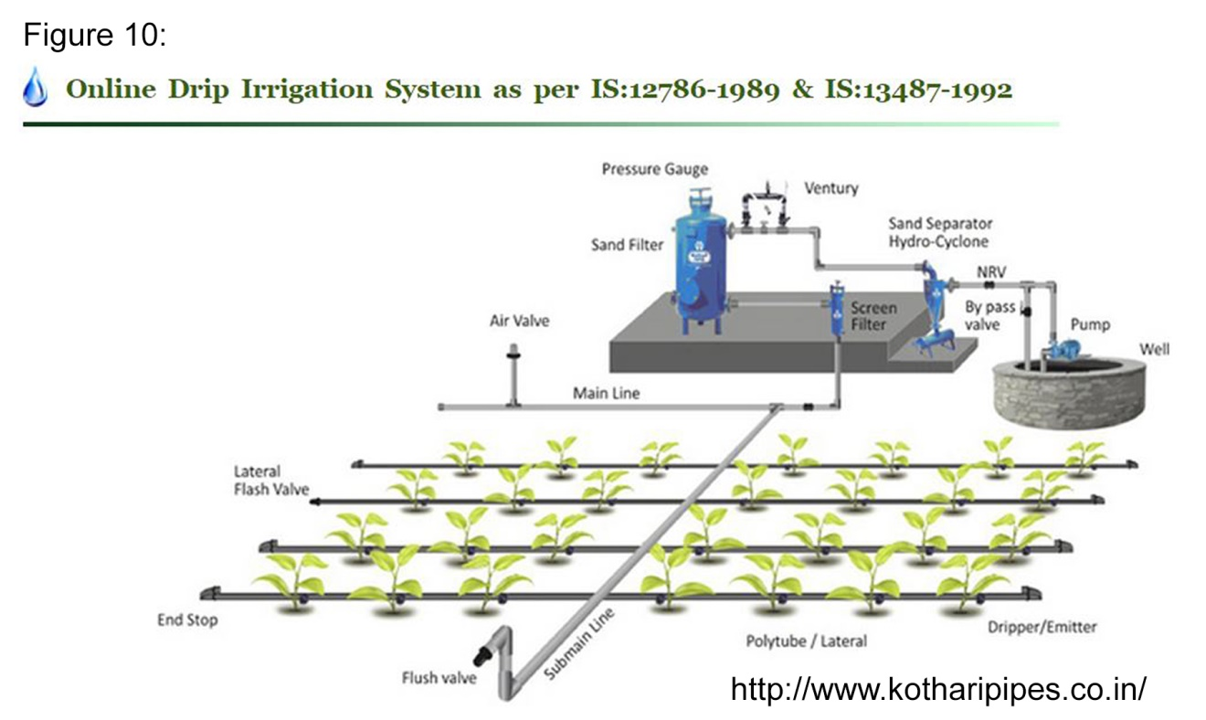
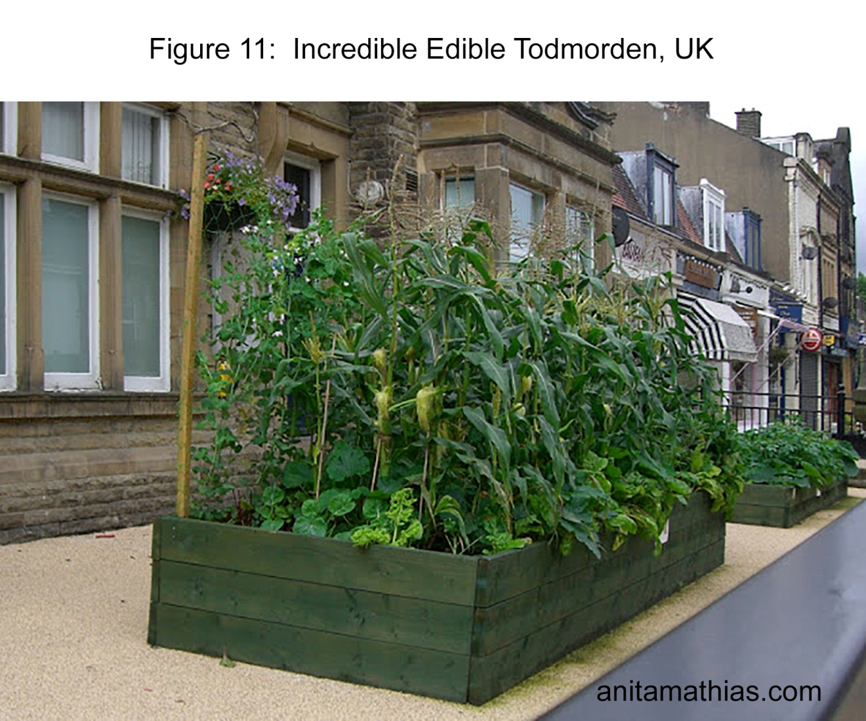

End of Figures
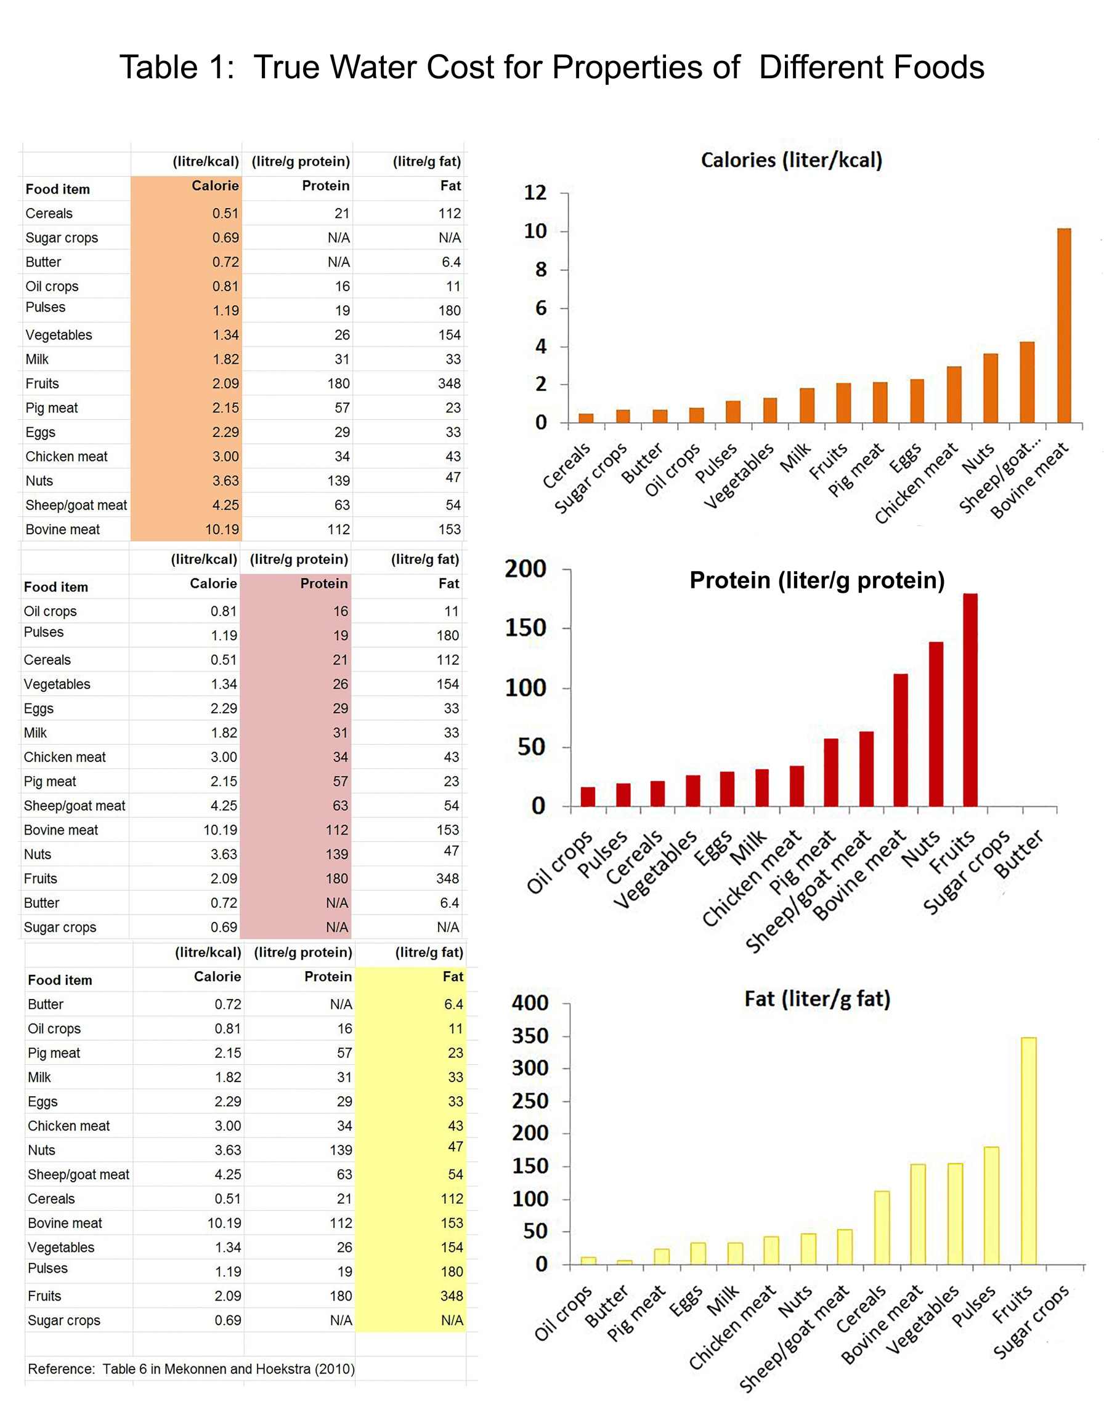

End of Manuscript

